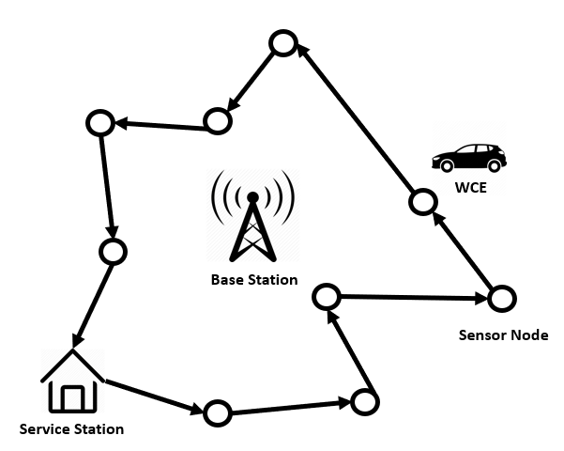

Figure 1. Typical example of WRSN in outdoor environment

.